**Part 1: Display the current time on I2C 7-segment display**

**Steps:**

Turn ON the switches for the i2c 7-segment display

Turn ON the switches for the i2c OLED display

Turn OFF other switches

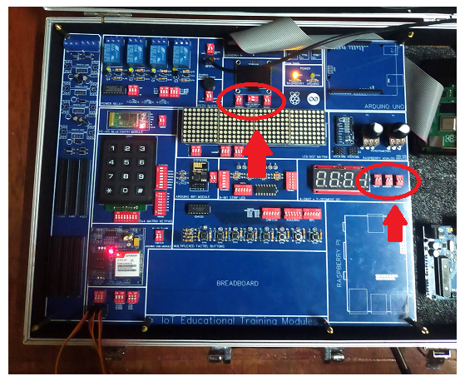

On the raspberry pi desktop open any python IDE such as Thony or Geany and use the following code then run the script

**Python Code:**

**#**basic import to get access on time function, identify the board and enable #bus input/output

import time

import board

import busio

#adafruit_ht16k33 libraries for the i2c 7 segments

from adafruit_ht16k33 import segments

#import OLED i2c display libraries

from pathlib import Path

from luma.core.interface.serial import i2c, spi, pcf8574

from luma.core.interface.parallel import bitbang_6800

from luma.core.render import canvas

from luma.oled.device import ssd1306, ssd1309, ssd1325, ssd1331, sh1106, ws0010

from PIL import ImageFont

#set up the default font

font = ImageFont.load_default()

#importing custom fonts using the file location of the .ttf files

font_mc = ImageFont.truetype('/home/pi/Desktop/programs/MainMenu/Minecraft.ttf', 32)

font_mcsmall = ImageFont.truetype('/home/pi/Desktop/programs/MainMenu/Minecraft.ttf', 16)

#OLED i2c lcd display addressing

serial = i2c(port=1, address=0x3C)

#defining the type of the OLED i2c device

device = sh1106(serial)

#Set up the screen dimention

x=0

top=0

width = device.width

height = device.height

#7 segments setups

from time import strftime

# Create the I2C interface.

i2c = busio.I2C(board.SCL, board.SDA)

# Create the LED segment class.

# This creates a 7 segment 4 character display:

display = segments.Seg7x4(i2c)

# Clear the display.

display.fill(0)

#forever loop

while(1):

#OLED lcd display

with canvas(device) as draw:

draw.text((x, top+30), "<Display Time>" , font=font_mcsmall, fill=255)

#i2c 7-segment time display

display.print(strftime("%I:%M"))

**Output:**

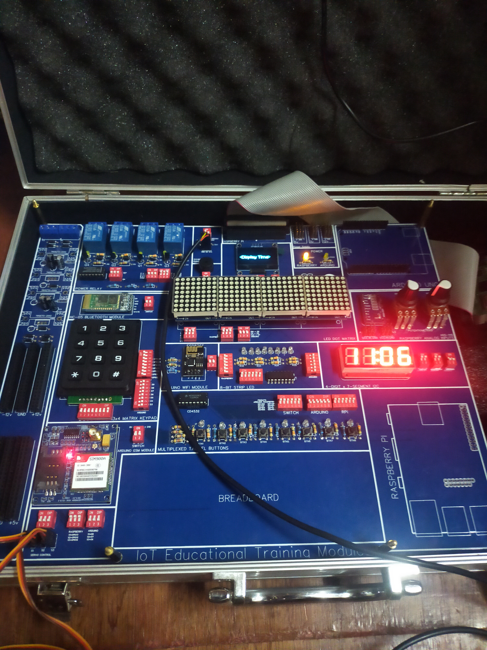

**Part 2: Analog Reading using ADS-1115 and OLED display**

**Steps:**

Turn ON the switches for i2c OLED display

The ADS-1115 is always active and connected to the I2C connection

Turn OFF all the other switches

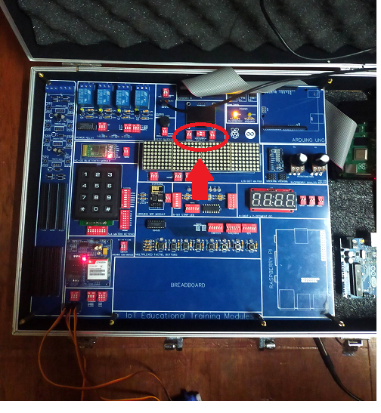

On the raspberry pi desktop open any python IDE such as Thony or Geany and use the following code then run the script

**Python Code:**

**#**basic import to get access on time function, identify the board and enable #bus input/output

**import RPi.GPIO as GPIO**

import busio

import board

GPIO.setwarnings(False)

#oled display Imports and setups

from pathlib import Path

from luma.core.interface.serial import i2c, spi, pcf8574

from luma.core.interface.parallel import bitbang_6800

from luma.core.render import canvas

from luma.oled.device import ssd1306, ssd1309, ssd1325, ssd1331, sh1106, ws0010

from PIL import ImageFont

font = ImageFont.load_default()

font_mc = ImageFont.truetype('/home/pi/Desktop/programs/MainMenu/Minecraft.ttf', 32)

font_mcsmall = ImageFont.truetype('/home/pi/Desktop/programs/MainMenu/Minecraft.ttf', 16)

serial = i2c(port=1, address=0x3C)

device = sh1106(serial)

x=0

top=0

width = device.width

height = device.height

menurun = 1

#main function

def analogreaders():

global menurun

#adafruit ads-1115 library imports

import adafruit_ads1x15.ads1115 as ADS

from adafruit_ads1x15.analog_in import AnalogIn

# Create the I2C bus

i2c = busio.I2C(board.SCL, board.SDA)

# Create the ADC object using the I2C bus

ads = ADS.ADS1115(i2c)

# you can specify an I2C adress instead of the default 0x48

# ads = ADS.ADS1115(i2c, address=0x49)

chan = AnalogIn(ads, ADS.P0)

chan1 = AnalogIn(ads, ADS.P1)

chan2 = AnalogIn(ads, ADS.P2)

chan3 = AnalogIn(ads, ADS.P3)

# Create differential input between channel 0 and 1

# chan = AnalogIn(ads, ADS.P0, ADS.P1)

#forever loop

while(menurun==1):

with canvas(device) as draw:

draw.text((x+40, top+2), "Raw" , font=font, fill=255)

draw.text((x+80, top+2), "Voltage" , font=font, fill=255)

draw.rectangle((0,0,width,height), outline=0, fill=0)

draw.text((x+40, top), "Raw" , font=font, fill=255)

draw.text((x+80, top), "Voltage" , font=font, fill=255)

#analog 0

draw.text((x+15, top+10), "A0" , font=font, fill=255)

draw.text((x+40, top+10), str(chan.value) , font=font, fill=255)

draw.text((x+80, top+10), str(chan.voltage) , font=font, fill=255)

#analog1

draw.text((x+15, top+20), "A1", font=font, fill=255)

draw.text((x+40, top+20), str(chan1.value) , font=font, fill=255)

draw.text((x+80, top+20), str(chan1.voltage) , font=font, fill=255)

#analog2

draw.text((x+15, top+30), "A2", font=font, fill=255)

draw.text((x+40, top+30), str(chan2.value) , font=font, fill=255)

draw.text((x+80, top+30), str(chan2.voltage) , font=font, fill=255)

#analog3

draw.text((x+15, top+40), "A3", font=font, fill=255)

draw.text((x+40, top+40), str(chan3.value) , font=font, fill=255)

draw.text((x+80, top+40), str(chan3.voltage) , font=font, fill=255)

#calling main function

analogreaders()

**Output:**

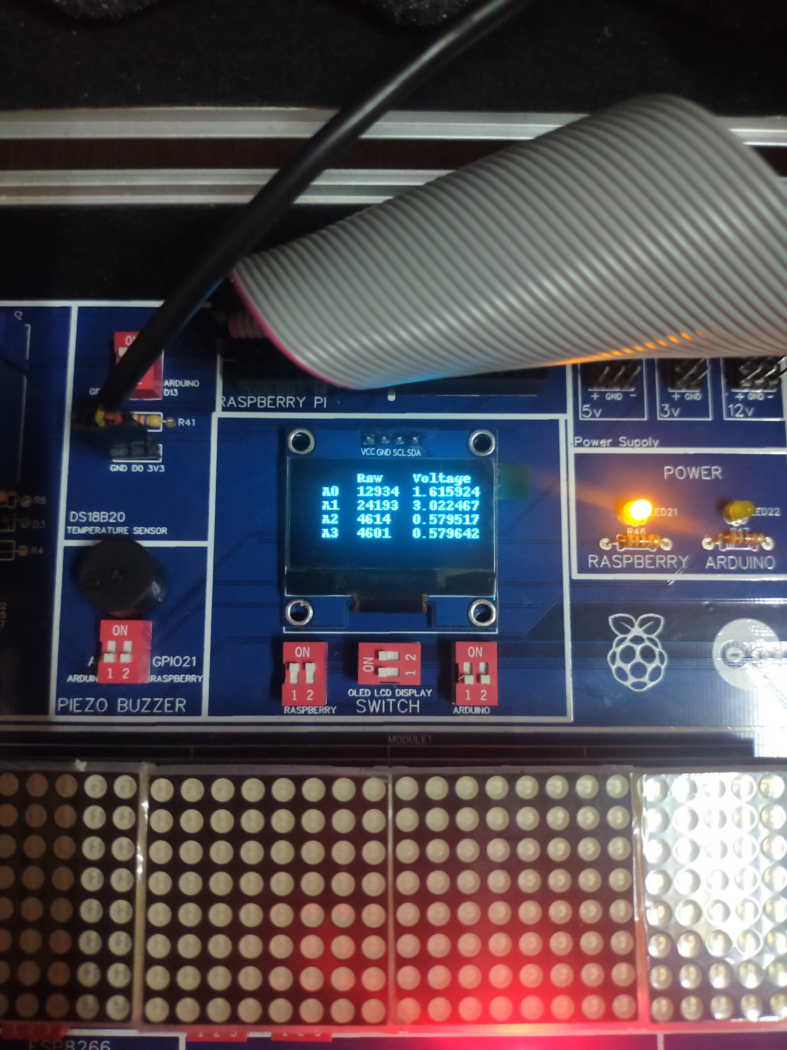

**Part 3: Message Display using Dot Matrix Module**

**Steps:**

Turn ON the switches for the Dot Matrix Module Connection

Turn OFF all the other switches

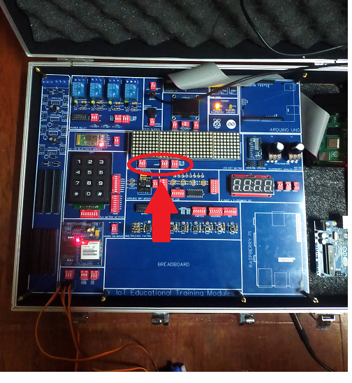

On the raspberry pi desktop open any python IDE such as Thony or Geany and use the following code then run the script

**Python Code:**

**#imports for time and argument parse libraries**

import time

import argparse

#import for the Dot matrix Display

from luma.led_matrix.device import max7219

from luma.core.interface.serial import spi, noop

from luma.core.legacy import show_message

from luma.core.legacy.font import proportional, CP437_FONT

#setup for the Dot Matrix Display

def output(n, block_orientation, rotate, inreverse, text):

# create matrix device

serial = spi(port=0, device=0, gpio=noop())

device = max7219(serial, cascaded=n or 1, block_orientation=block_orientation,

rotate=rotate or 0, blocks_arranged_in_reverse_order=inreverse)

print(text)

show_message(device, text, fill="white", font=proportional(CP437_FONT), scroll_delay=0.05)

time.sleep(1)

if __name__ == "__main__":

#setup for the Dot Matrix message viewing

parser = argparse.ArgumentParser(description='view_message arguments',

formatter_class=argparse.ArgumentDefaultsHelpFormatter)

#define how many Dot matrix is cascaded using variable n

parser.add_argument('--cascaded', '-n', type=int, default=4, help='Number of cascaded MAX7219 LED matrices')

#define the block orientation

parser.add_argument('--block-orientation', type=int, default=-90, choices=[0, 90, -90], help='Corrects block orientation when wired vertically')

#define rotation

parser.add_argument('--rotate', type=int, default=0, choices=[0, 1, 2, 3], help='Rotate display 0=0°, 1=90°, 2=180°, 3=270°')

#define order

parser.add_argument('--reverse-order', type=bool, default=False, help='Set to true if blocks are in reverse order')

#define the message to be displayed

parser.add_argument('--text', '-t', default='>>HELLO WORLD<<', help='Set text message')

args = parser.parse_args()

try:

#call the main function

output(args.cascaded, args.block_orientation, args.rotate, args.reverse_order, args.text)

except KeyboardInterrupt:

pass

**Output:**

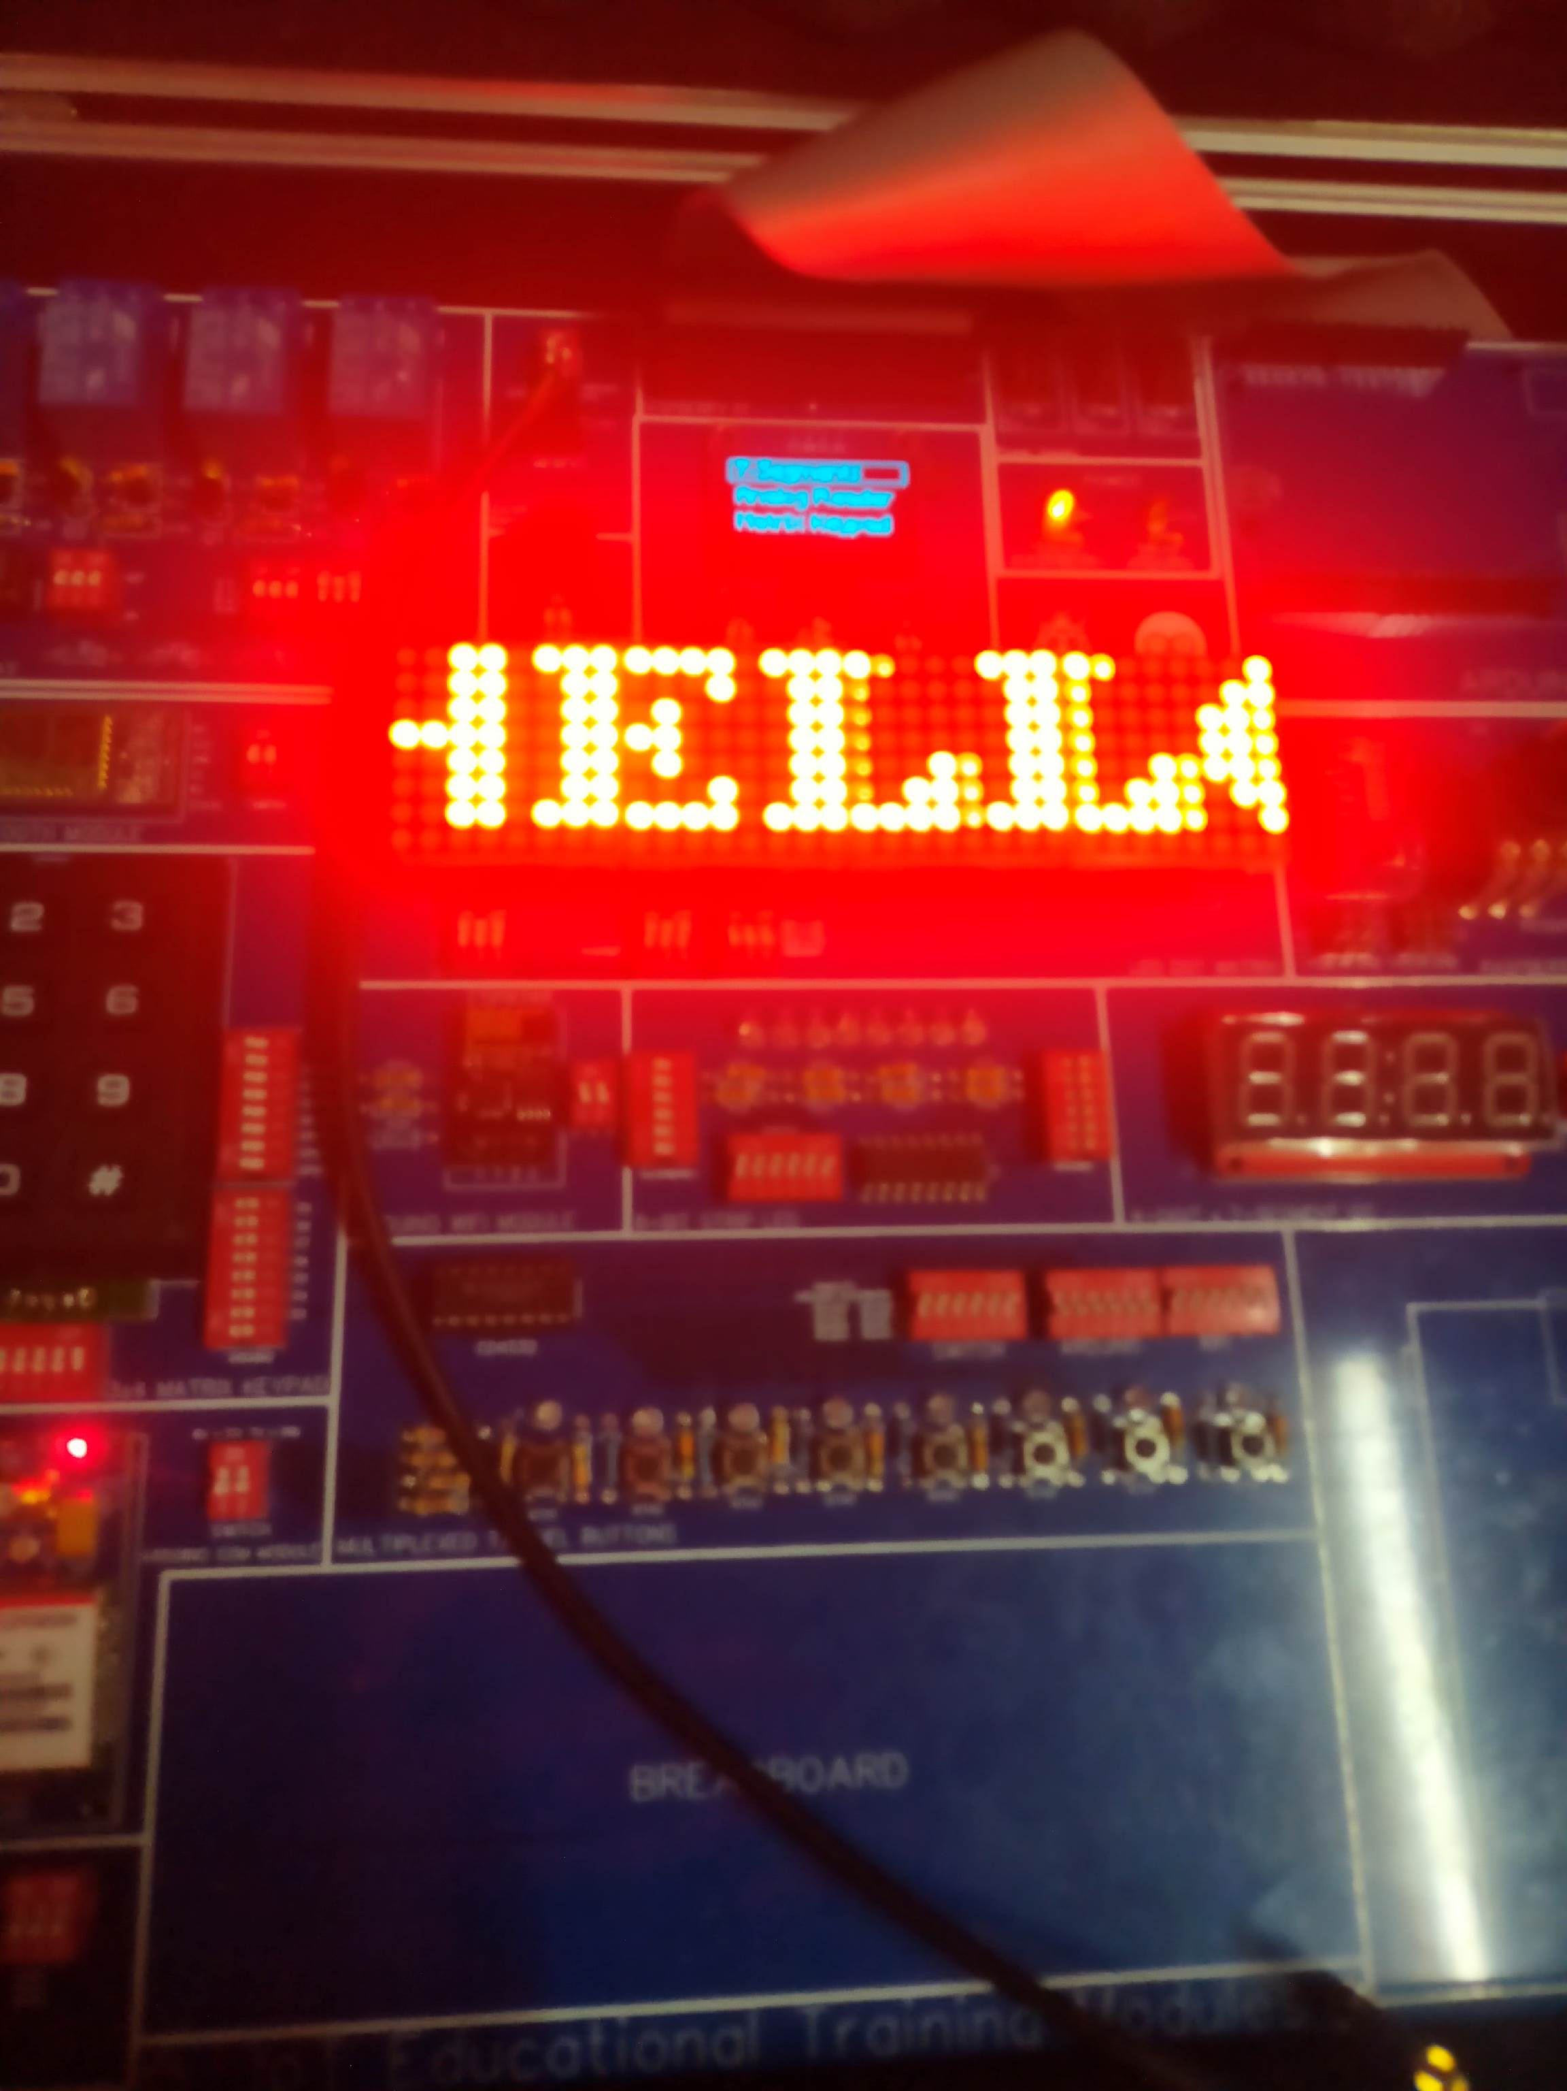

**Part 4: Dot Matrix Display with switch**

**Steps:**

Turn ON the switch for the Dot Matrix Display

Turn ON the switch for the 8-bit switches

Turn ON the switch for the i2c OLED display

Turn OFF all the other switches

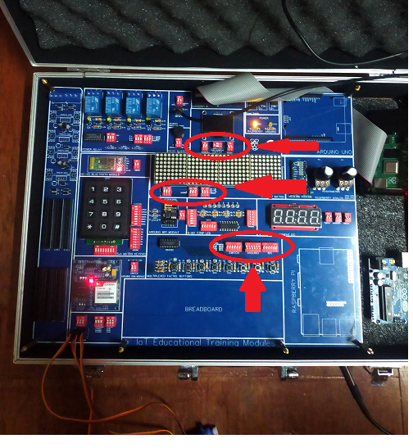

On the raspberry pi desktop open any python IDE such as Thony or Geany and use the following code then run the script

**Python Code:**

**#**basic import to get access on time function, identify the board and enable #bus input/output

import RPi.GPIO as GPIO

import time

import board

GPIO.setmode(GPIO.BCM)

GPIO.setwarnings(False)

#dot matrix library imports

from luma.core.interface.serial import spi, noop

from luma.core.render import canvas

from luma.core.virtual import viewport

from luma.led_matrix.device import max7219

from luma.core.legacy import text, show_message

from luma.core.legacy.font import proportional, CP437_FONT, LCD_FONT

#dot matrix setup

serial = spi(port=0, device=0, gpio=noop())

device = max7219(serial, width=32, height=8, block_orientation=-90)

device.contrast(5)

virtual = viewport(device, width=32, height=16)

#oled display Imports and setups

from pathlib import Path

from luma.core.interface.serial import i2c, spi, pcf8574

from luma.core.interface.parallel import bitbang_6800

from luma.core.render import canvas

from luma.oled.device import ssd1306, ssd1309, ssd1325, ssd1331, sh1106, ws0010

from PIL import ImageFont

font = ImageFont.load_default()

font_mc = ImageFont.truetype('/home/pi/Desktop/programs/MainMenu/Minecraft.ttf', 32)

font_mcsmall = ImageFont.truetype('/home/pi/Desktop/programs/MainMenu/Minecraft.ttf', 16)

serial = i2c(port=1, address=0x3C)

device = sh1106(serial)

x=0

top=0

width = device.width

height = device.height

#buttons setups

#7, 17, 9, 24

GPIO.setup(7, GPIO.IN)

GPIO.setup(17, GPIO.IN)

GPIO.setup(9, GPIO.IN)

GPIO.setup(24, GPIO.IN)

menurun = 1

#empty string array to store inputs

s = []

#main function

def matrixWithSwitch():

global menurun

global s

#function that convert list items to a single string

def listToString(s):

str1 = ""

return(str1.join(s))

while(menurun==1):

#OLED Display

with canvas(device) as draw:

draw.text((0, 1), "Matrix Keypad" , font=font_mcsmall, fill="white")

draw.text((x +50, top+21), "" , font=font_mc, fill="white")

#Dot Matrix display, display the number equivalent to the button pressed

with canvas(virtual) as draw:

text(draw, (0, 0), str(listToString(s)), fill="white", font=proportional(LCD_FONT))

#button decoding

#buttons

if GPIO.input(7):

byte1 = 1

else:

byte1 = 0

if GPIO.input(17):

byte2 = 1

else:

byte2 = 0

if GPIO.input(9):

byte3 = 1

else:

byte3 = 0

if GPIO.input(24):

byte4 = 1

else:

byte4 = 0

#When the button is pressed the equivalent number is inserted to the empty array then converted in a single string

#button 1

if(byte1==0 and byte2==0 and byte3==0 and byte4==1):

print("Button 1 pressed")

s.insert(0,'1')

#button 2

if(byte1==1 and byte2==0 and byte3==0 and byte4==1):

print("Button 2 pressed")

s.insert(0,'2')

#button 3

if(byte1==0 and byte2==1 and byte3==0 and byte4==1):

print("Button 3 pressed")

s.insert(0,'3')

#button 4

if(byte1==1 and byte2==1 and byte3==0 and byte4==1):

print("Button 4 pressed")

s.insert(0,'4')

#button 5

if(byte1==0 and byte2==0 and byte3==1 and byte4==1):

print("Button 5 pressed")

s.insert(0,'5')

#button 6

if(byte1==1 and byte2==0 and byte3==1 and byte4==1):

print("Button 6 pressed")

s.insert(0,'6')

#button 7

if(byte1==0 and byte2==1 and byte3==1 and byte4==1):

print("Button 7 pressed")

s.insert(0,'7')

#button 8

if(byte1==1 and byte2==1 and byte3==1 and byte4==1):

print("Button 8 pressed")

s.insert(0, '8')

#calls the main function

matrixWithSwitch()

**Output:**

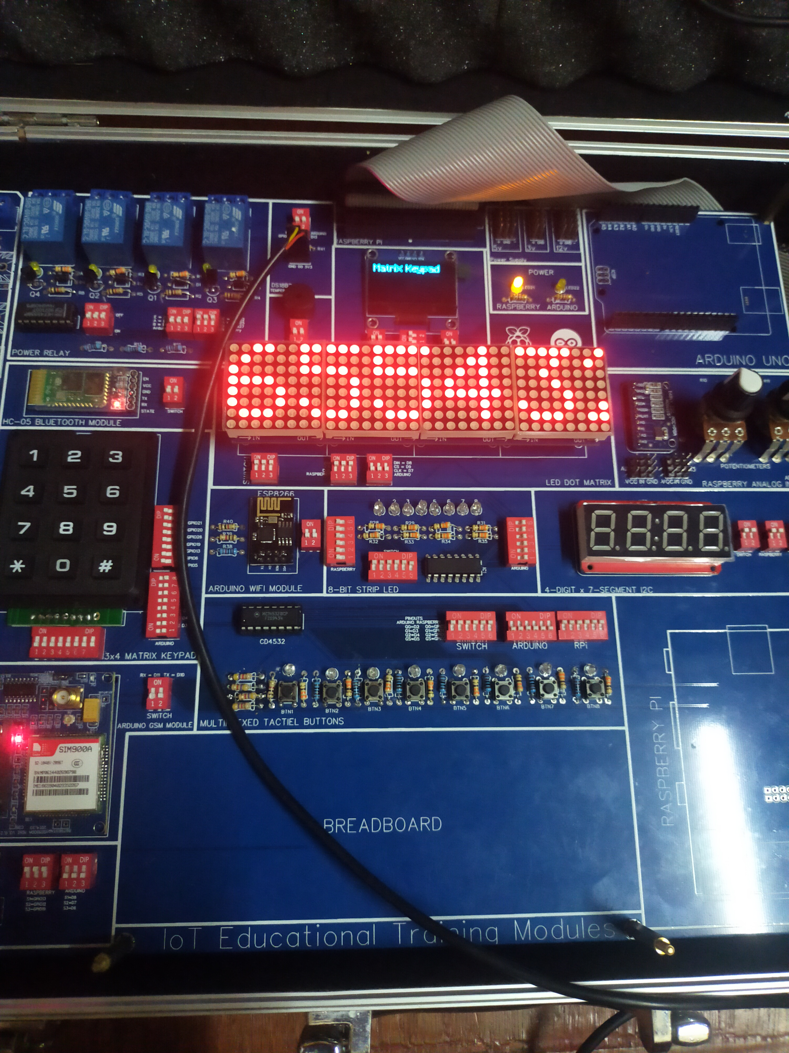

**Part 5: Dot Matrix Display and 7-segments display with 3x4 Matrix Keypad**

**Steps:**

Turn ON the switches for i2c OLED display

Turn ON the switches for 3x4 Matrix keypad

Turn ON the switches for Dot Matrix Display

Turn ON the switches for i2c 7-segment display

Turn OFF all the other switches

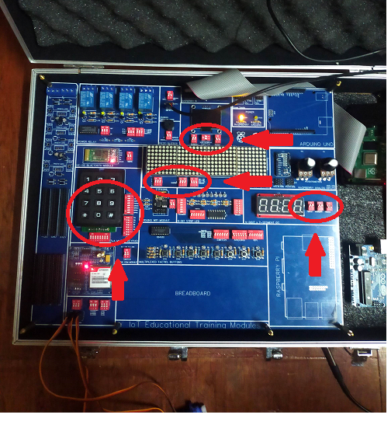

On the raspberry pi desktop open any python IDE such as Thony or Geany and use the following code then run the script

**Python Code:**

import RPi.GPIO as GPIO

import time

import board

GPIO.setmode(GPIO.BCM)

GPIO.setwarnings(False)

#Dot matrix libraries import

from luma.core.interface.serial import spi, noop

from luma.core.render import canvas

from luma.core.virtual import viewport

from luma.led_matrix.device import max7219

from luma.core.legacy import text, show_message

from luma.core.legacy.font import proportional, CP437_FONT, LCD_FONT

#dot matrix setup

serial = spi(port=0, device=0, gpio=noop())

device = max7219(serial, width=32, height=8, block_orientation=-90)

device.contrast(5)

virtual = viewport(device, width=32, height=16)

#matrix keypad library import

import digitalio

import adafruit_matrixkeypad

#matrix keypad setups

cols = [digitalio.DigitalInOut(x) for x in (board.D13, board.D5, board.D26)]

rows = [digitalio.DigitalInOut(x) for x in (board.D6, board.D21, board.D20, board.D19)]

keys = ((1, 2, 3), (4, 5, 6), (7, 8, 9), ("*", 0, "#"))

keypad = adafruit_matrixkeypad.Matrix_Keypad(rows, cols, keys)

sample = 0

spacing = 20

#oled display Imports

from pathlib import Path

from luma.core.interface.serial import i2c, spi, pcf8574

from luma.core.interface.parallel import bitbang_6800

from luma.core.render import canvas

from luma.oled.device import ssd1306, ssd1309, ssd1325, ssd1331, sh1106, ws0010

from PIL import ImageFont

font = ImageFont.load_default()

font_mc = ImageFont.truetype('/home/pi/Desktop/programs/MainMenu/Minecraft.ttf', 32)

font_mcsmall = ImageFont.truetype('/home/pi/Desktop/programs/MainMenu/Minecraft.ttf', 16)

serial = i2c(port=1, address=0x3C)

device = sh1106(serial)

x=0

top=0

width = device.width

height = device.height

#7segments imports

import busio

import board

import busio

from adafruit_ht16k33 import segments

#7 segments setups

from time import strftime

# Create the I2C interface.

i2c = busio.I2C(board.SCL, board.SDA)

# Create the LED segment class.

# This creates a 7 segment 4 character display:

display = segments.Seg7x4(i2c)

# Clear the display.

display.fill(0)

menurun = 1

s = []

def matrixKeypad():

global menurun

global sample

global spacing

global s

# converts list items to a single array

def listToString(s):

str1= ""

return(str1.join(s))

#forever loop

while(menurun==1):

#keypad logic

keys = keypad.pressed_keys

if keys:

if(keys==[1]):

sample = 1

s.insert(0,'1')

if(keys==[2]):

sample = 2

s.insert(0,'2')

if(keys==[3]):

sample = 3

s.insert(0,'3')

if(keys==[4]):

sample = 4

s.insert(0,'4')

if(keys==[5]):

sample = 4

s.insert(0,'5')

if(keys==[6]):

sample = 6

s.insert(0,'6')

if(keys==[7]):

sample = 7

s.insert(0,'7')

if(keys==[8]):

sample = 8

s.insert(0,'8')

if(keys==[9]):

sample = 9

s.insert(0,'9')

if(keys==[0]):

sample = 0

s.insert(0,'0')

if(keys==["*"]):

sample = "*"

s.insert(0,'*')

if(keys==["#"]):

sample = "#"

s.insert(0,'#')

display.print(sample)

time.sleep(0.2)

#oled display

with canvas(device) as draw:

draw.text((0, 1), "Matrix Keypad" , font=font_mcsmall, fill="white")

draw.text((x +50, top+21), str(sample) , font=font_mc, fill="white")

#dot matrix diplay

with canvas(virtual) as draw:

text(draw, (0, 0), str(listToString(s)), fill="white", font=proportional(LCD_FONT))

#calls main function

matrixKeypad()

**Output:**

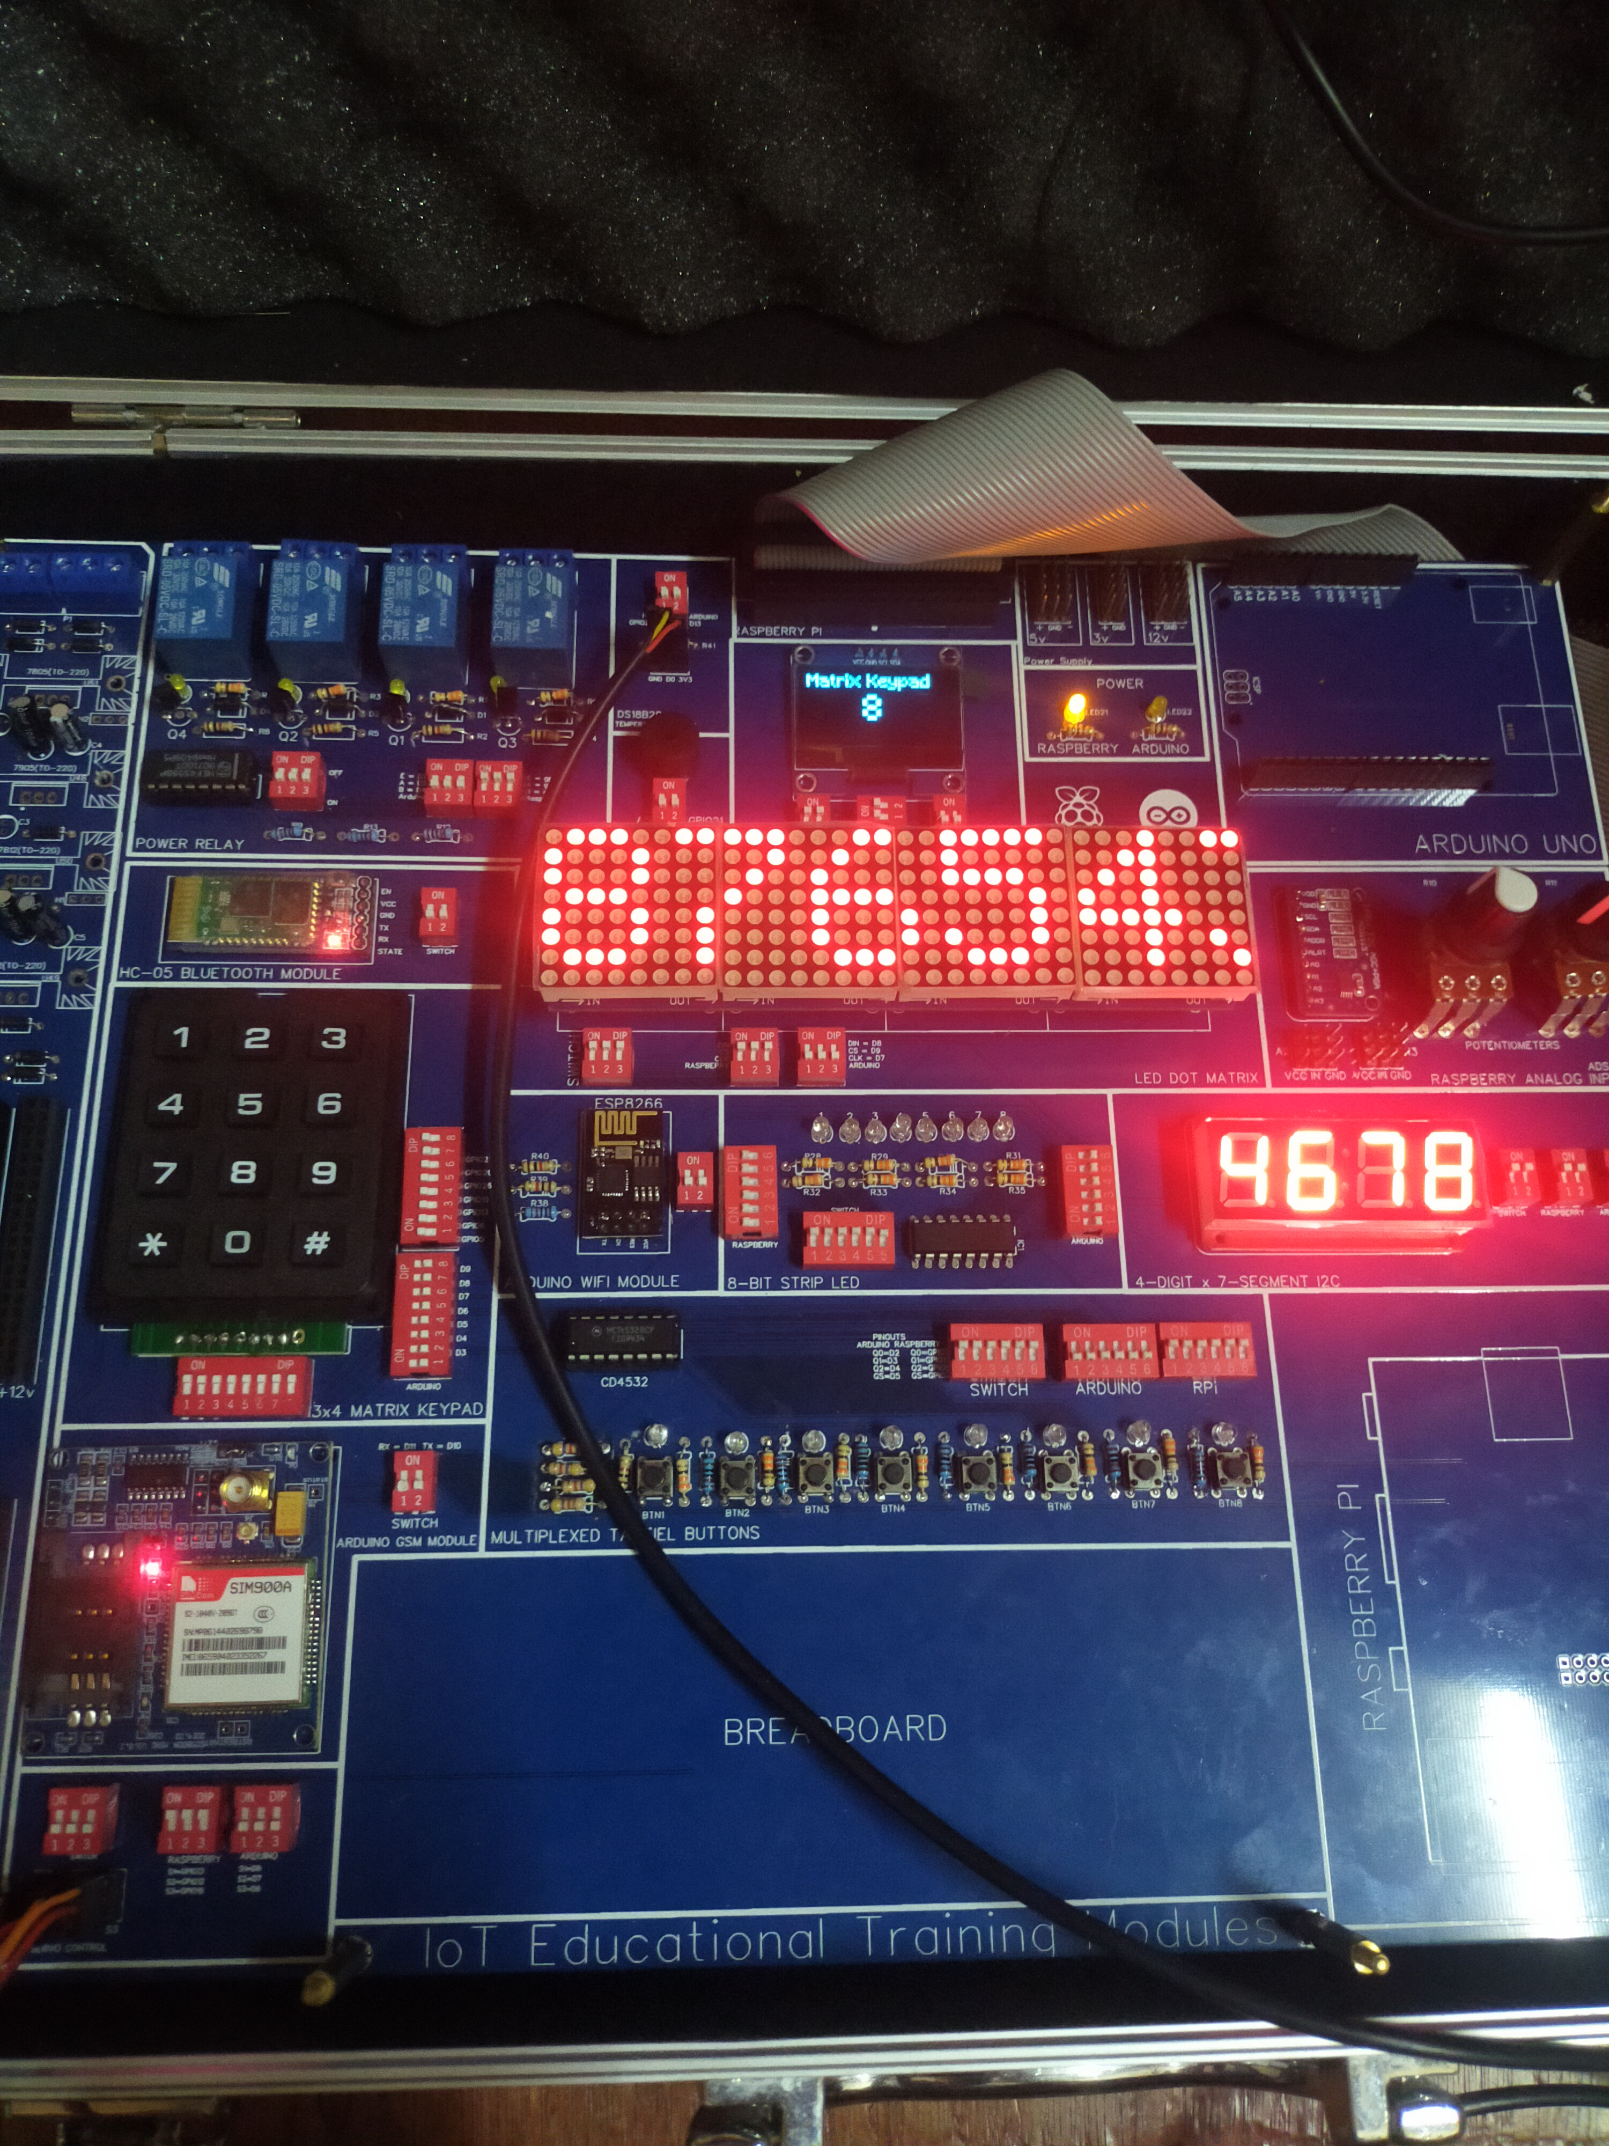

**Part 6: 8-bit led control using buttons**

**Steps:**

Turn ON the switches for i2c OLED display

Turn ON the switches for the Buttons

Turn ON the switches for the 8-bit strip led

Turn OFF all the other switches

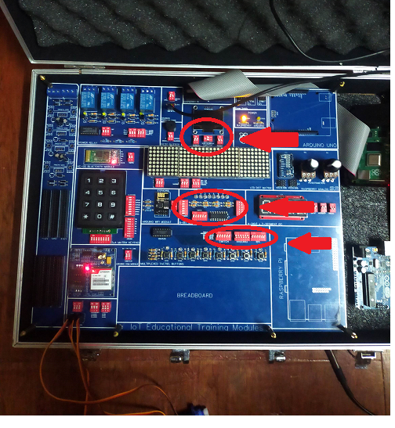

On the raspberry pi desktop open any python IDE such as Thony or Geany and use the following code then run the script

**Python Code:**

import RPi.GPIO as GPIO

import time

import board

GPIO.setmode(GPIO.BCM)

GPIO.setwarnings(False)

#oled display Imports and setups

from pathlib import Path

from luma.core.interface.serial import i2c, spi, pcf8574

from luma.core.interface.parallel import bitbang_6800

from luma.core.render import canvas

from luma.oled.device import ssd1306, ssd1309, ssd1325, ssd1331, sh1106, ws0010

from PIL import ImageFont

font = ImageFont.load_default()

font_mc = ImageFont.truetype('/home/pi/Desktop/programs/MainMenu/Minecraft.ttf', 32)

font_mcsmall = ImageFont.truetype('/home/pi/Desktop/programs/MainMenu/Minecraft.ttf', 16)

serial = i2c(port=1, address=0x3C)

device = sh1106(serial)

x=0

top=0

width = device.width

height = device.height

#buttons

#7, 17, 9, 24

GPIO.setup(7, GPIO.IN)

GPIO.setup(17, GPIO.IN)

GPIO.setup(9, GPIO.IN)

GPIO.setup(24, GPIO.IN)

#shift register setup

databit = 23

latch = 16

clock = 12

# led strip set to low at the beginning

led1 = 0

led2 = 0

led3 = 0

led4 = 0

led5 = 0

led6 = 0

led7 = 0

led8 = 0

#pin and button setups

GPIO.setup(databit, GPIO.OUT)

GPIO.setup(latch, GPIO.OUT)

GPIO.setup(clock, GPIO.OUT)

#7, 17, 9, 24

GPIO.setup(7, GPIO.IN)

GPIO.setup(17, GPIO.IN)

GPIO.setup(9, GPIO.IN)

GPIO.setup(24, GPIO.IN)

delay = 300

time.sleep(0.2)

GPIO.output(latch, 0)

menurun = 1

def ledstrip():

global led1

global led2

global led3

global led4

global led5

global led6

global led7

global led8

global menurun

#main function for sending data to shift register

def register():

GPIO.output(latch, 0)

GPIO.output(databit, led8)

GPIO.output(clock,1)

GPIO.output(clock,0)

GPIO.output(databit, led7)

GPIO.output(clock,1)

GPIO.output(clock,0)

GPIO.output(databit, led6)

GPIO.output(clock,1)

GPIO.output(clock,0)

GPIO.output(databit, led5)

GPIO.output(clock,1)

GPIO.output(clock,0)

GPIO.output(databit, led4)

GPIO.output(clock,1)

GPIO.output(clock,0)

GPIO.output(databit, led3)

GPIO.output(clock,1)

GPIO.output(clock,0)

GPIO.output(databit, led2)

GPIO.output(clock,1)

GPIO.output(clock,0)

GPIO.output(databit, led1)

GPIO.output(clock,1)

GPIO.output(clock,0)

GPIO.output(latch,1)

register()

#main forever loop

while(menurun==1):

#oled display

with canvas(device) as draw:

draw.text((0, 1), "8-bits" , font=font_mcsmall, fill="white")

draw.text((x, top+21), str(led1) + str(led2) + str(led3) + str(led4) + str(led5) + str(led6) + str(led7) + str(led8) , font=font_mc, fill="white")

#buttons

#button decoder

if GPIO.input(7):

byte1 = 1

else:

byte1 = 0

if GPIO.input(17):

byte2 = 1

else:

byte2 = 0

if GPIO.input(9):

byte3 = 1

else:

byte3 = 0

if GPIO.input(24):

byte4 = 1

else:

byte4 = 0

#button 1

if(byte1==0 and byte2==0 and byte3==0 and byte4==1):

if(led1==1 ):

led1 = 0

time.sleep(0.2)

elif(led1==0 ):

led1 = 1

time.sleep(0.2)

register()

#button 2

if(byte1==1 and byte2==0 and byte3==0 and byte4==1):

if(led2==1 ):

led2 = 0

time.sleep(0.2)

elif(led2==0 ):

led2 = 1

time.sleep(0.2)

register()

#button 3

if(byte1==0 and byte2==1 and byte3==0 and byte4==1):

if(led3==1 ):

led3 = 0

time.sleep(0.2)

elif(led3==0 ):

led3 = 1

time.sleep(0.2)

register()

#button 4

if(byte1==1 and byte2==1 and byte3==0 and byte4==1):

if(led4==1 ):

led4 = 0

time.sleep(0.2)

elif(led4==0 ):

led4 = 1

time.sleep(0.2)

register()

#button 5

if(byte1==0 and byte2==0 and byte3==1 and byte4==1):

if(led5==1 ):

led5 = 0

time.sleep(0.2)

elif(led5==0 ):

led5 = 1

time.sleep(0.2)

register()

#button 6

if(byte1==1 and byte2==0 and byte3==1 and byte4==1):

if(led6==1 ):

led6 = 0

time.sleep(0.2)

elif(led6==0 ):

led6 = 1

time.sleep(0.2)

register()

#button 7

if(byte1==0 and byte2==1 and byte3==1 and byte4==1):

if(led7==1 ):

led7 = 0

time.sleep(0.2)

elif(led7==0 ):

led7 = 1

time.sleep(0.2)

register()

#button 8

if(byte1==1 and byte2==1 and byte3==1 and byte4==1):

if(led8==1 ):

led8 = 0

time.sleep(0.2)

elif(led8==0 ):

led8 = 1

time.sleep(0.2)

register()

#calling main function

ledstrip()

**Output:**

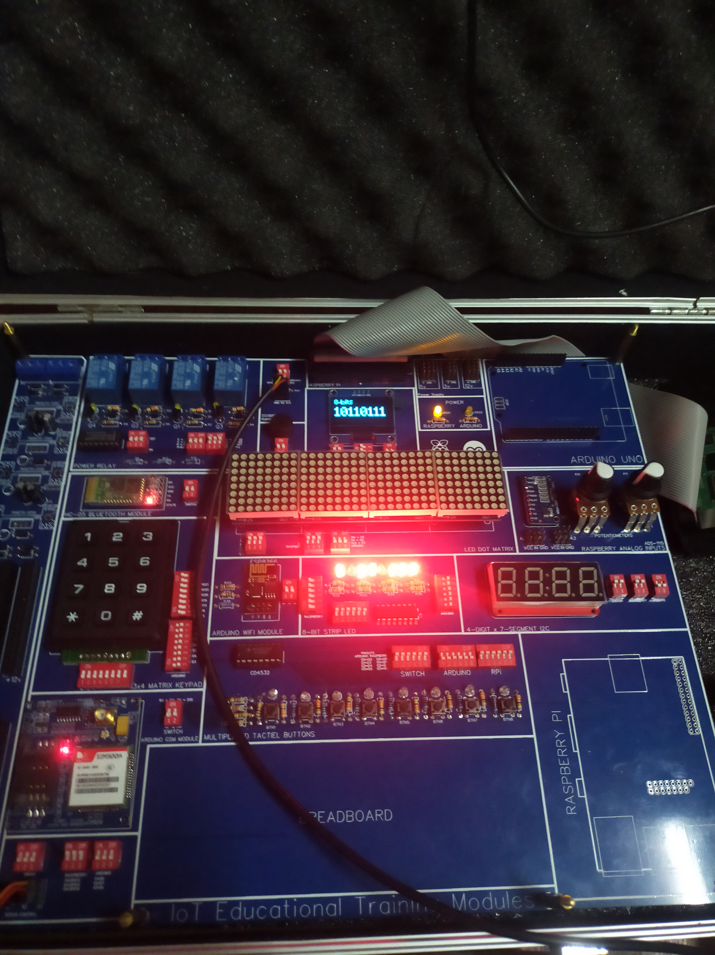

**Part 7: Power Relay control using button**

**Steps:**

Turn ON switches for the Power relays

Turn ON switches for the i2c OLED display

Turn ON the switches for the buttons

Turn OFF all other switches

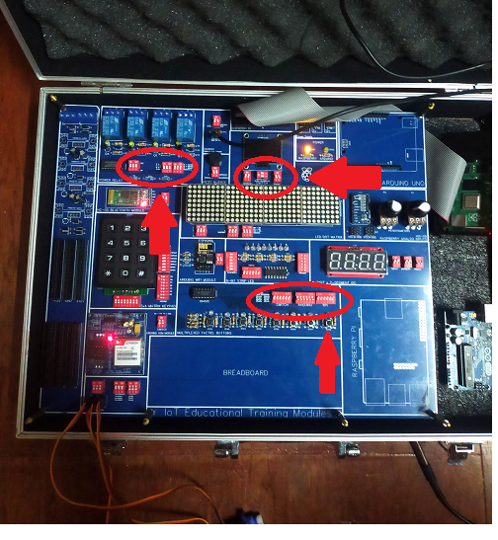

On the raspberry pi desktop open any python IDE such as Thony or Geany and use the following code then run the script

**Python Code:**

import RPi.GPIO as GPIO

import time

import board

GPIO.setmode(GPIO.BCM)

GPIO.setwarnings(False)

#oled display Imports

from pathlib import Path

from luma.core.interface.serial import i2c, spi, pcf8574

from luma.core.interface.parallel import bitbang_6800

from luma.core.render import canvas

from luma.oled.device import ssd1306, ssd1309, ssd1325, ssd1331, sh1106, ws0010

from PIL import ImageFont

font = ImageFont.load_default()

font_mc = ImageFont.truetype('/home/pi/Desktop/programs/MainMenu/Minecraft.ttf', 32)

font_mcsmall = ImageFont.truetype('/home/pi/Desktop/programs/MainMenu/Minecraft.ttf', 16)

serial = i2c(port=1, address=0x3C)

device = sh1106(serial)

x=0

top=0

width = device.width

height = device.height

#Relay setups

GPIO.setup(22,GPIO.OUT)

GPIO.setup(25,GPIO.OUT)

GPIO.setup(27,GPIO.OUT)

#enable active low

GPIO.output(22,GPIO.HIGH)

#relay numbers

RelayNum = 0

#buttons

#7, 17, 9, 24

GPIO.setup(7, GPIO.IN)

GPIO.setup(17, GPIO.IN)

GPIO.setup(9, GPIO.IN)

GPIO.setup(24, GPIO.IN)

menurun = 1

def powerRelay():

global menurun

global RelayNum

while(menurun==1):

with canvas(device) as draw:

draw.text((0, 1), " Power Relay" , font=font_mcsmall, fill="white")

draw.text((x, top+21), " Control" , font=font_mcsmall, fill="white")

if(RelayNum==1):

draw.text((x, top+41), " Relay 1: ON" , font=font_mcsmall, fill="white")

elif(RelayNum==2):

draw.text((x, top+41), " Relay 2: ON" , font=font_mcsmall, fill="white")

elif(RelayNum==3):

draw.text((x, top+41), " Relay 3: ON" , font=font_mcsmall, fill="white")

elif(RelayNum==4):

draw.text((x, top+41), " Relay 4: ON" , font=font_mcsmall, fill="white")

elif(RelayNum==0):

draw.text((x, top+41), " OFF" , font=font_mcsmall, fill="white")

if GPIO.input(7):

byte1 = 1

else:

byte1 = 0

if GPIO.input(17):

byte2 = 1

else:

byte2 = 0

if GPIO.input(9):

byte3 = 1

else:

byte3 = 0

if GPIO.input(24):

byte4 = 1

else:

byte4 = 0

#button 1

if(byte1==0 and byte2==0 and byte3==0 and byte4==1):

print("Button 1 pressed")

RelayNum=1

#button 2

if(byte1==1 and byte2==0 and byte3==0 and byte4==1):

print("Button 2 pressed")

RelayNum=2

#button 3

if(byte1==0 and byte2==1 and byte3==0 and byte4==1):

print("Button 3 pressed")

RelayNum=3

#button 4

if(byte1==1 and byte2==1 and byte3==0 and byte4==1):

print("Button 4 pressed")

RelayNum=4

#button 5

if(byte1==0 and byte2==0 and byte3==1 and byte4==1):

print("Button 5 pressed")

RelayNum=0

#button 6

if(byte1==1 and byte2==0 and byte3==1 and byte4==1):

print("Button 6 pressed")

menurun=0

#button 7

if(byte1==0 and byte2==1 and byte3==1 and byte4==1):

print("Button 7 pressed")

#button 8

if(byte1==1 and byte2==1 and byte3==1 and byte4==1):

print("Button 8 pressed")

#relays process

if(RelayNum==1):

# #relay1

GPIO.output(25,GPIO.LOW)

GPIO.output(27,GPIO.LOW)

GPIO.output(22,GPIO.LOW)

elif(RelayNum==2):

# #relay2

GPIO.output(25,GPIO.HIGH)

GPIO.output(27,GPIO.LOW)

GPIO.output(22,GPIO.LOW)

elif(RelayNum==3):

# #relay3

GPIO.output(25,GPIO.LOW)

GPIO.output(27,GPIO.HIGH)

GPIO.output(22,GPIO.LOW)

elif(RelayNum==4):

#relay4

GPIO.output(25,GPIO.HIGH)

GPIO.output(27,GPIO.HIGH)

else:

GPIO.output(22,GPIO.HIGH)

#calls main function

powerRelay()

**Output:**

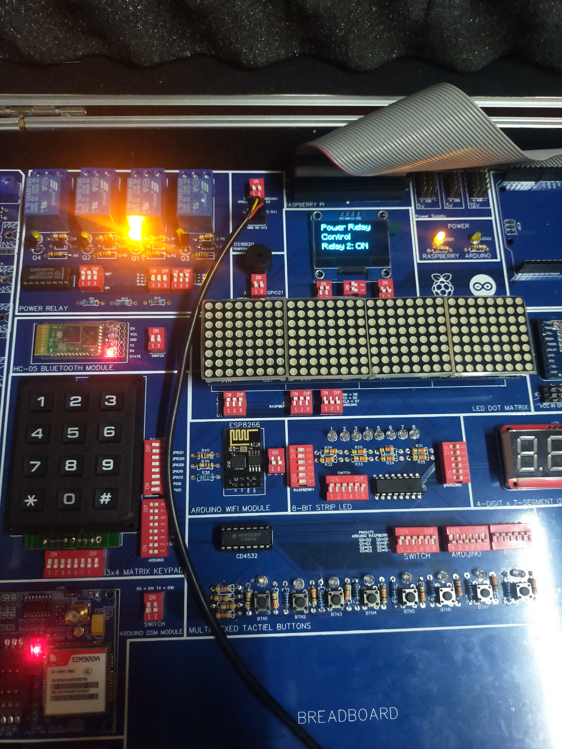

**Part 8: Servo Control using buttons**

**Steps:**

Turn ON the switches for the Servos

Turn ON the switches for the buttons

Turn ON the switches for i2c OLED display

Turn OFF all the other switches

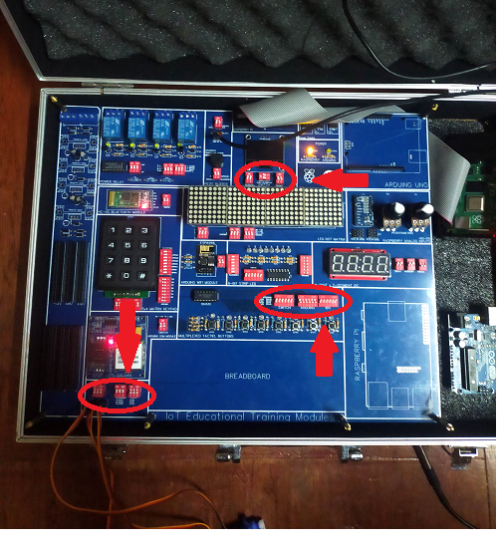

On the raspberry pi desktop open any python IDE such as Thony or Geany and use the following code then run the script

**Python Code:**

import time

import RPi.GPIO as GPIO

GPIO.setmode(GPIO.BCM)

GPIO.setwarnings(False)

#SERVOs

GPIO.setup(12, GPIO.OUT)

GPIO.setup(13, GPIO.OUT)

GPIO.setup(19, GPIO.OUT)

#buttons

#7, 17, 9, 24

GPIO.setup(7, GPIO.IN)

GPIO.setup(17, GPIO.IN)

GPIO.setup(9, GPIO.IN)

GPIO.setup(24, GPIO.IN)

#oled display Imports

from pathlib import Path

from luma.core.interface.serial import i2c, spi, pcf8574

from luma.core.interface.parallel import bitbang_6800

from luma.core.render import canvas

from luma.oled.device import ssd1306, ssd1309, ssd1325, ssd1331, sh1106, ws0010

from PIL import ImageFont

font = ImageFont.load_default()

font_mc = ImageFont.truetype('/home/pi/Desktop/programs/MainMenu/Minecraft.ttf', 32)

font_mcsmall = ImageFont.truetype('/home/pi/Desktop/programs/MainMenu/Minecraft.ttf', 16)

serial = i2c(port=1, address=0x3C)

device = sh1106(serial)

x=0

top=0

width = device.width

height = device.height

menurun = 1

def servoRun():

global menurun

a = '\u00b0'

servoselector = 1

p1 = GPIO.PWM(13, 50)

p1.start(0)

rot1 = 0

angle1 = 0

p2 = GPIO.PWM(12,50)

p2.start(0)

rot2 = 0

angle2 = 0

angleall = 0

p3 = GPIO.PWM(19,50)

p3.start(0)

rot3 = 0

angle3 =0

degree_sign= u'\N{DEGREE SIGN}'

while menurun == 1:

if GPIO.input(7):

byte1 = 1

else:

byte1 = 0

if GPIO.input(17):

byte2 = 1

else:

byte2 = 0

if GPIO.input(9):

byte3 = 1

else:

byte3 = 0

if GPIO.input(24):

byte4 = 1

else:

byte4 = 0

#print(byte1, byte2,byte3,byte4)

#time.sleep(0.5)

#button 1

if(byte1==0 and byte2==0 and byte3==0 and byte4==1):

print("Button 1 pressed")

if servoselector <4:

servoselector = servoselector +1

time.sleep(0.3)

else:

servoselector = 1

time.sleep(0.3)

#button 5

if(byte1==0 and byte2==0 and byte3==1 and byte4==1):

print("Button 5 pressed")

#button 6

if(byte1==1 and byte2==0 and byte3==1 and byte4==1):

print("Button 6 pressed")

#button 7

if(byte1==0 and byte2==1 and byte3==1 and byte4==1):

print("Button 7 pressed")

#button 8

if(byte1==1 and byte2==1 and byte3==1 and byte4==1):

print("Button 8 pressed")

with canvas(device) as draw:

draw.rectangle(device.bounding_box, outline="white", fill="black")

if servoselector == 1:

draw.text((x+5, top+5), "Servo 1 online" , font=font_mcsmall, fill=255)

draw.text((x+5, top+20), "Angle:" , font=font_mcsmall, fill=255)

draw.text((x+60, top+20), str(angle1) , font=font_mcsmall, fill=255)

if angle1 == 0 :

draw.text((x+50, top+50), "Min" , font=font_mcsmall, fill=255)

if angle1 == 180 :

draw.text((x+50, top+50), "Max" , font=font_mcsmall, fill=255)

if servoselector == 2:

draw.text((x+5, top+5), "Servo 2 online" , font=font_mcsmall, fill=255)

draw.text((x+5, top+20), "Angle:" , font=font_mcsmall, fill=255)

draw.text((x+60, top+20), str(angle2) , font=font_mcsmall, fill=255)

if angle2 == 0 :

draw.text((x+50, top+50), "Min" , font=font_mcsmall, fill=255)

if angle2 == 180 :

draw.text((x+50, top+50), "Max" , font=font_mcsmall, fill=255)

if servoselector == 3:

draw.text((x+5, top+5), "Servo 3 online" , font=font_mcsmall, fill=255)

draw.text((x+5, top+20), "Angle:" , font=font_mcsmall, fill=255)

draw.text((x+60, top+20), str(angle3) , font=font_mcsmall, fill=255)

if angle3 == 0 :

draw.text((x+50, top+50), "Min" , font=font_mcsmall, fill=255)

if angle3 == 180 :

draw.text((x+50, top+50), "Max" , font=font_mcsmall, fill=255)

if servoselector == 4:

draw.text((x+5, top+5), "All servo online" , font=font_mcsmall, fill=255)

draw.text((x+5, top+20), "Angle:" , font=font_mcsmall, fill=255)

draw.text((x+60, top+20), str(angleall) , font=font_mcsmall, fill=255)

if angleall == 0 :

draw.text((x+50, top+50), "Min" , font=font_mcsmall, fill=255)

if angleall == 180 :

draw.text((x+50, top+50), "Max" , font=font_mcsmall, fill=255)

if servoselector ==1:

if rot1==0:

p1.ChangeDutyCycle(2)

angle1= 0

if rot1==1:

p1.ChangeDutyCycle(4)

angle1 = 45

if rot1==2:

p1.ChangeDutyCycle(7)

angle1 = 90

if rot1==3:

p1.ChangeDutyCycle(9.5)

angle1 = 135

if rot1==4:

p1.ChangeDutyCycle(12)

angle1= 180

#button 2

if(byte1==1 and byte2==0 and byte3==0 and byte4==1):

print("Button 2 pressed")

if rot1>0:

rot1=rot1-1

print(rot1)

time.sleep(0.3)

#button 3

if(byte1==0 and byte2==1 and byte3==0 and byte4==1):

print("Button 3 pressed")

if rot1<4:

rot1=rot1+1

print(rot1)

time.sleep(0.3)

if servoselector == 2:

if rot2==0:

p2.ChangeDutyCycle(2)

angle2 = 0

if rot2==1:

p2.ChangeDutyCycle(4)

angle2 = 45

if rot2==2:

p2.ChangeDutyCycle(7)

angle2 = 90

if rot2==3:

p2.ChangeDutyCycle(9.5)

angle2 = 135

if rot2==4:

p2.ChangeDutyCycle(12)

angle2 = 180

#button 2

if(byte1==1 and byte2==0 and byte3==0 and byte4==1):

print("Button 2 pressed")

if rot2>0:

rot2=rot2-1

print(rot2)

time.sleep(0.3)

#button 3

if(byte1==0 and byte2==1 and byte3==0 and byte4==1):

print("Button 3 pressed")

if rot2<4:

rot2=rot2+1

print(rot2)

time.sleep(0.3)

if servoselector ==3:

if rot3==0:

p3.ChangeDutyCycle(2)

angle3 = 0

if rot3==1:

p3.ChangeDutyCycle(4)

angle3 = 45

if rot3==2:

p3.ChangeDutyCycle(7)

angle3 = 90

if rot3==3:

p3.ChangeDutyCycle(9.5)

angle3 = 135

if rot3==4:

p3.ChangeDutyCycle(12)

angle3 = 180

#button 2

if(byte1==1 and byte2==0 and byte3==0 and byte4==1):

print("Button 2 pressed")

if rot3>0:

rot3=rot3-1

print(rot3)

time.sleep(0.3)

#button 3

if(byte1==0 and byte2==1 and byte3==0 and byte4==1):

print("Button 3 pressed")

if rot3<4:

rot3=rot3+1

print(rot3)

time.sleep(0.3)

if servoselector == 4:

if rot2==0:

p3.ChangeDutyCycle(2)

p2.ChangeDutyCycle(2)

p1.ChangeDutyCycle(2)

angleall = 0

if rot2==1:

p3.ChangeDutyCycle(4)

p2.ChangeDutyCycle(4)

p1.ChangeDutyCycle(4)

angleall = 45

if rot2==2:

p3.ChangeDutyCycle(7)

p2.ChangeDutyCycle(7)

p1.ChangeDutyCycle(7)

angleall = 90

if rot2==3:

p3.ChangeDutyCycle(9.5)

p2.ChangeDutyCycle(9.5)

p1.ChangeDutyCycle(9.5)

angleall = 135

if rot2==4:

p3.ChangeDutyCycle(12)

p2.ChangeDutyCycle(12)

p1.ChangeDutyCycle(12)

angleall = 180

#button 2

if(byte1==1 and byte2==0 and byte3==0 and byte4==1):

print("Button 2 pressed")

if rot2>0:

rot2=rot2-1

print(rot2)

time.sleep(0.3)

#button 3

if(byte1==0 and byte2==1 and byte3==0 and byte4==1):

print("Button 3 pressed")

if rot2<4:

rot2=rot2+1

print(rot2)

time.sleep(0.3)

if menurun == 0:

break

#button 4

if(byte1==1 and byte2==1 and byte3==0 and byte4==1):

print("Button 4 pressed")

print("exit success")

menurun = 0

while True:

servoRun()

**Output:**

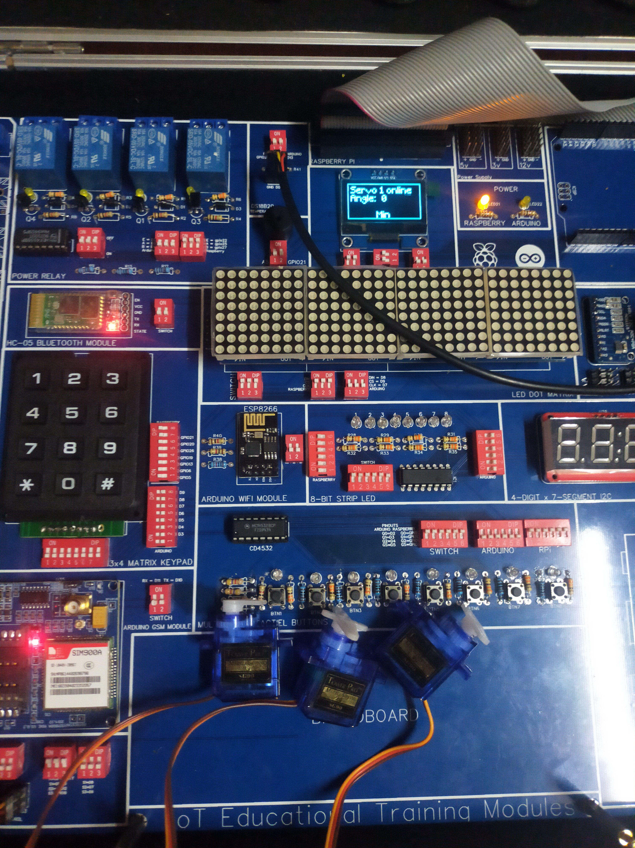

**Part 9: Simple led**

**Steps:**

Turn ON switches for the 8-bit strip led

Turn ON switches for the OLED display

Turn OFF all the other switches

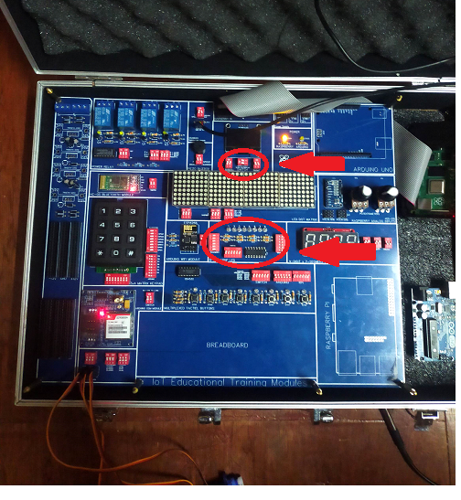

On the raspberry pi desktop open any python IDE such as Thony or Geany and use the following code then run the script

**Python Code:**

import RPi.GPIO as GPIO

import time

import board

GPIO.setmode(GPIO.BCM)

GPIO.setwarnings(False)

#oled display Imports

from pathlib import Path

from luma.core.interface.serial import i2c, spi, pcf8574

from luma.core.interface.parallel import bitbang_6800

from luma.core.render import canvas

from luma.oled.device import ssd1306, ssd1309, ssd1325, ssd1331, sh1106, ws0010

from PIL import ImageFont

font = ImageFont.load_default()

font_mc = ImageFont.truetype('/home/pi/Desktop/programs/MainMenu/Minecraft.ttf', 32)

font_mcsmall = ImageFont.truetype('/home/pi/Desktop/programs/MainMenu/Minecraft.ttf', 16)

serial = i2c(port=1, address=0x3C)

device = sh1106(serial)

x=0

top=0

width = device.width

height = device.height

# led strip

databit = 23

latch = 16

clock = 12

#order of bits 7,6,5,4,3,2,1,8

led1 = 0

led2 = 0

led3 = 0

led4 = 0

led5 = 0

led6 = 0

led7 = 0

led8 = 0

GPIO.setup(databit, GPIO.OUT)

GPIO.setup(latch, GPIO.OUT)

GPIO.setup(clock, GPIO.OUT)

#7, 17, 9, 24

GPIO.setup(7, GPIO.IN)

GPIO.setup(17, GPIO.IN)

GPIO.setup(9, GPIO.IN)

GPIO.setup(24, GPIO.IN)

delay = 300

time.sleep(0.2)

GPIO.output(latch, 0)

menurun = 1

def ledDemo():

global led1

global led2

global led3

global led4

global led5

global led6

global led7

global led8

global menurun

GPIO.output(latch, 0)

GPIO.output(databit, led8)

GPIO.output(clock,1)

GPIO.output(clock,0)

GPIO.output(databit, led7)

GPIO.output(clock,1)

GPIO.output(clock,0)

GPIO.output(databit, led6)

GPIO.output(clock,1)

GPIO.output(clock,0)

GPIO.output(databit, led5)

GPIO.output(clock,1)

GPIO.output(clock,0)

GPIO.output(databit, led4)

GPIO.output(clock,1)

GPIO.output(clock,0)

GPIO.output(databit, led3)

GPIO.output(clock,1)

GPIO.output(clock,0)

GPIO.output(databit, led2)

GPIO.output(clock,1)

GPIO.output(clock,0)

GPIO.output(databit, led1)

GPIO.output(clock,1)

GPIO.output(clock,0)

GPIO.output(latch,1)

while(menurun==1):

with canvas(device) as draw:

draw.text((x, top+21), "8 Leds" , font=font_mc, fill="white")

while(1):

for y in range(8):

GPIO.output(databit, 1)

GPIO.output(clock,1)

GPIO.output(clock,0)

GPIO.output(latch,1)

time.sleep(0.2)

GPIO.output(latch,0)

for y in range(8):

GPIO.output(databit, 0)

GPIO.output(clock,1)

GPIO.output(clock,0)

GPIO.output(latch,1)

time.sleep(0.2)

GPIO.output(latch,0)

ledDemo()

**Output:**

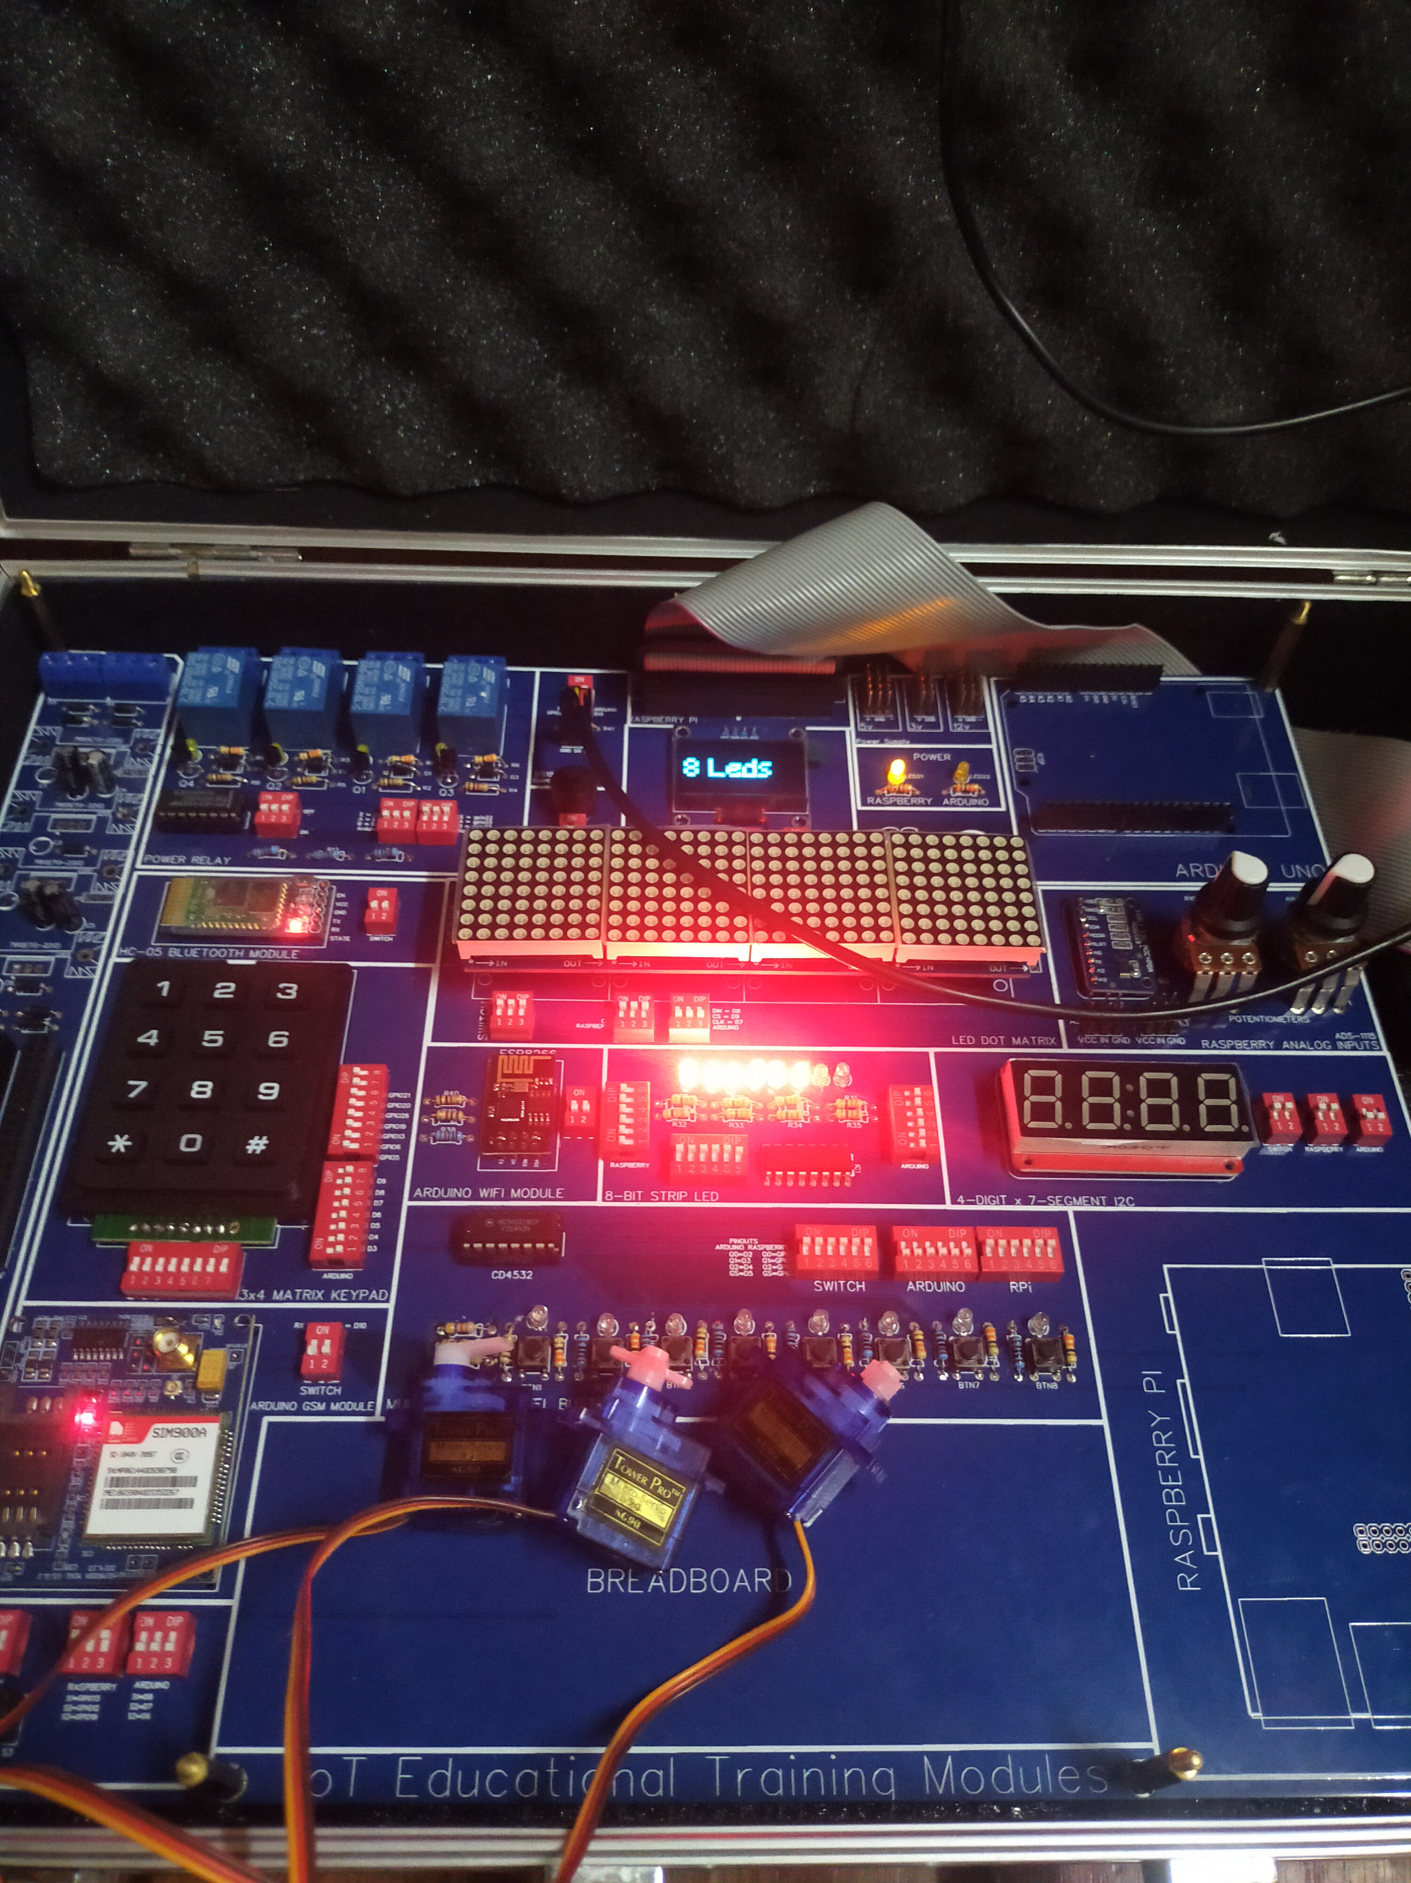

**Part 10: Temperature Sensor with Dot Matrix Display and OLED display**

**Steps:**

Turn ON the switches for the Temperature Sensor

Turn ON the switches for the Dot Matrix display

Turn ON the switches for the OLED display

Turn OFF all the other switches

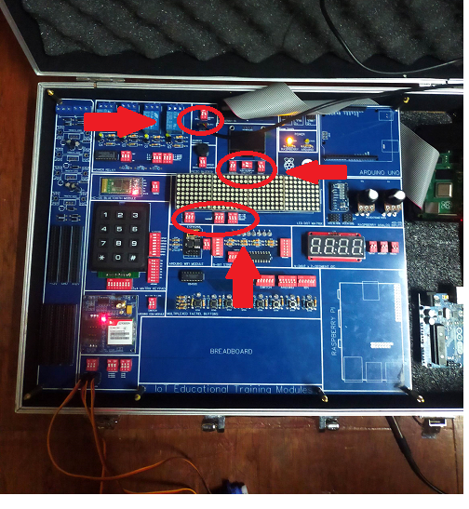

On the raspberry pi desktop open any python IDE such as Thony or Geany and use the following code then run the script

**Python Code:**

import RPi.GPIO as GPIO

from time import sleep, strftime

#dotmatrix

from luma.core.interface.serial import spi, noop

from luma.core.render import canvas

from luma.core.virtual import viewport

from luma.led_matrix.device import max7219

from luma.core.legacy import text, show_message

from luma.core.legacy.font import proportional, CP437_FONT, LCD_FONT

serial = spi(port=0, device=0, gpio=noop())

device = max7219(serial, width=32, height=8, block_orientation=-90)

device.contrast(5)

virtual = viewport(device, width=32, height=16)

import os

import glob

from pathlib import Path

from luma.core.interface.serial import i2c, spi, pcf8574

from luma.core.interface.parallel import bitbang_6800

from luma.core.render import canvas

from luma.oled.device import ssd1306, ssd1309, ssd1325, ssd1331, sh1106, ws0010

import time

from PIL import ImageFont

serial = i2c(port=1, address=0x3C)

device = sh1106(serial)

font = ImageFont.load_default()

font_mc = ImageFont.truetype('/home/pi/Desktop/programs/MainMenu/Minecraft.ttf', 32)

font_mcsmall = ImageFont.truetype('/home/pi/Desktop/programs/MainMenu/Minecraft.ttf', 16)

x=0

top= 0

menurun = True

def temp():

global menurun

while menurun == True:

if menurun == False:

break

os.system('modprobe w1-gpio')

os.system('modprobe w1-therm')

base_dir = '/sys/bus/w1/devices/'

device_folder = glob.glob(base_dir + '28*')[0]

device_file = device_folder + '/w1_slave'

def read_temp_raw():

f = open(device_file, 'r')

lines = f.readlines()

f.close()

return lines

def read_temp():

lines = read_temp_raw()

while lines[0].strip()[-3:] != 'YES':

lines = read_temp_raw()

equals_pos = lines[1].find('t=')

if equals_pos != -1:

temp_string = lines[1][equals_pos+2:]

temp_c = float(temp_string) / 1000.0

temp_f = temp_c * 9.0 / 5.0 + 32.0

return temp_c, temp_f

def read_tempC():

lines = read_temp_raw()

while lines[0].strip()[-3:] != 'YES':

lines = read_temp_raw()

equals_pos = lines[1].find('t=')

if equals_pos != -1:

temp_string = lines[1][equals_pos+2:]

temp_c = float(temp_string) / 1000.0

temp_f = temp_c * 9.0 / 5.0 + 32.0

return temp_c

while True:

with canvas(device) as draw:

draw.text((x, top+2), "Temperature Reading" , font=font, fill=255)

draw.text((x, top+20), "Celsius & Farhanheit" , font=font, fill=255)

draw.text((x, top+40), str(read_temp()) , font=font_mcsmall, fill=255)

print(read_temp())

with canvas(virtual) as draw:

text(draw, (0, 0), str(read_tempC()), fill="white", font=proportional(LCD_FONT))

temp()

**Output:**

